National Union of Disabled
Persons of Uganda
Understanding Disability and

Inclusion
1
Outline of the presentation
- Perspectives on disability
- Models of Disability
- Definitions of Disability
- Understanding barriers
- Critical issues that affects Persons with disabilities.
- Categories of Disabilities and Reasonable Accommodation needs
- Strategies for including persons with disabilities in the development process.
Brainstorming
- Who are “Persons with disabilities”?
- Which categories of disability do you know?
- What does “Segregation, Integration, Exclusion, inclusion of persons with disabilities” means?
Understanding the models of
disabilities
What community perspectives on
disability exists under
:
-
•
Traditional model
•
Medical model
•
Social model
•
Human rights model

What the Models content…
Questions
Traditional
Model
Medical
Model
Social
/Human
rights
Model
What is this way of
thinking about?
Curse, bad omen
Disease,
compassionate/
feeling pity
Acceptance,
equality, Rights,
Citizenship,
Participation,
What is its purpose?
Get rid, have
transmittable
diseases
Correct the
problem
Access, inclusion,
involvement
Where do people with
disabilities live?
Confined, hidden,
isolated
Rehabilitation 9i,
hospitals
community

What the Models content…
Questions
Traditional
Model
Medical
Model
Social
/Human
rights
Model
Who are the experts in
this model?
Elders,
traditional
healers
Medical doctors,
psychiatrist
Persons with
disabilities
themselves
What is their self
esteem like?
Low
Low
–
their mentality is
to be like the others able
bodied but are given
crutches, assistive
devices
Very high and
independent minded
How do people with
this level of self
-
esteem
usually behave?
Aggressive,
Inactive
Angry, depressed, not
cooperative, withdrawal
Interactive,
Acceptance

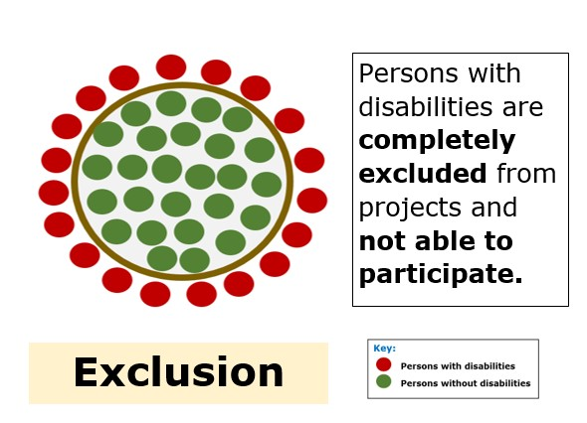
Exclusion:

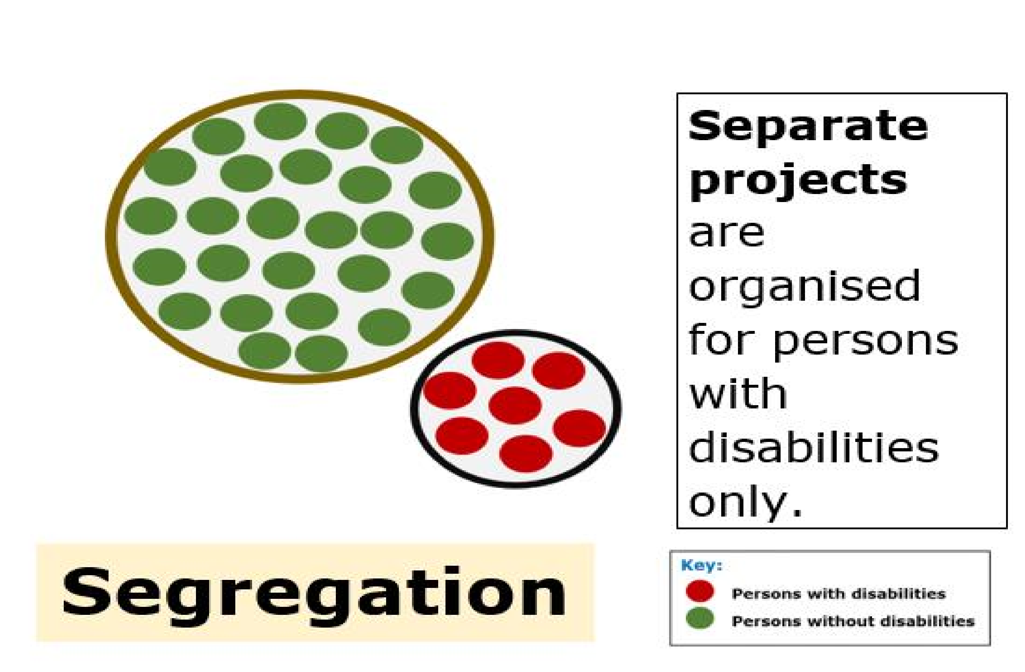
Segregation

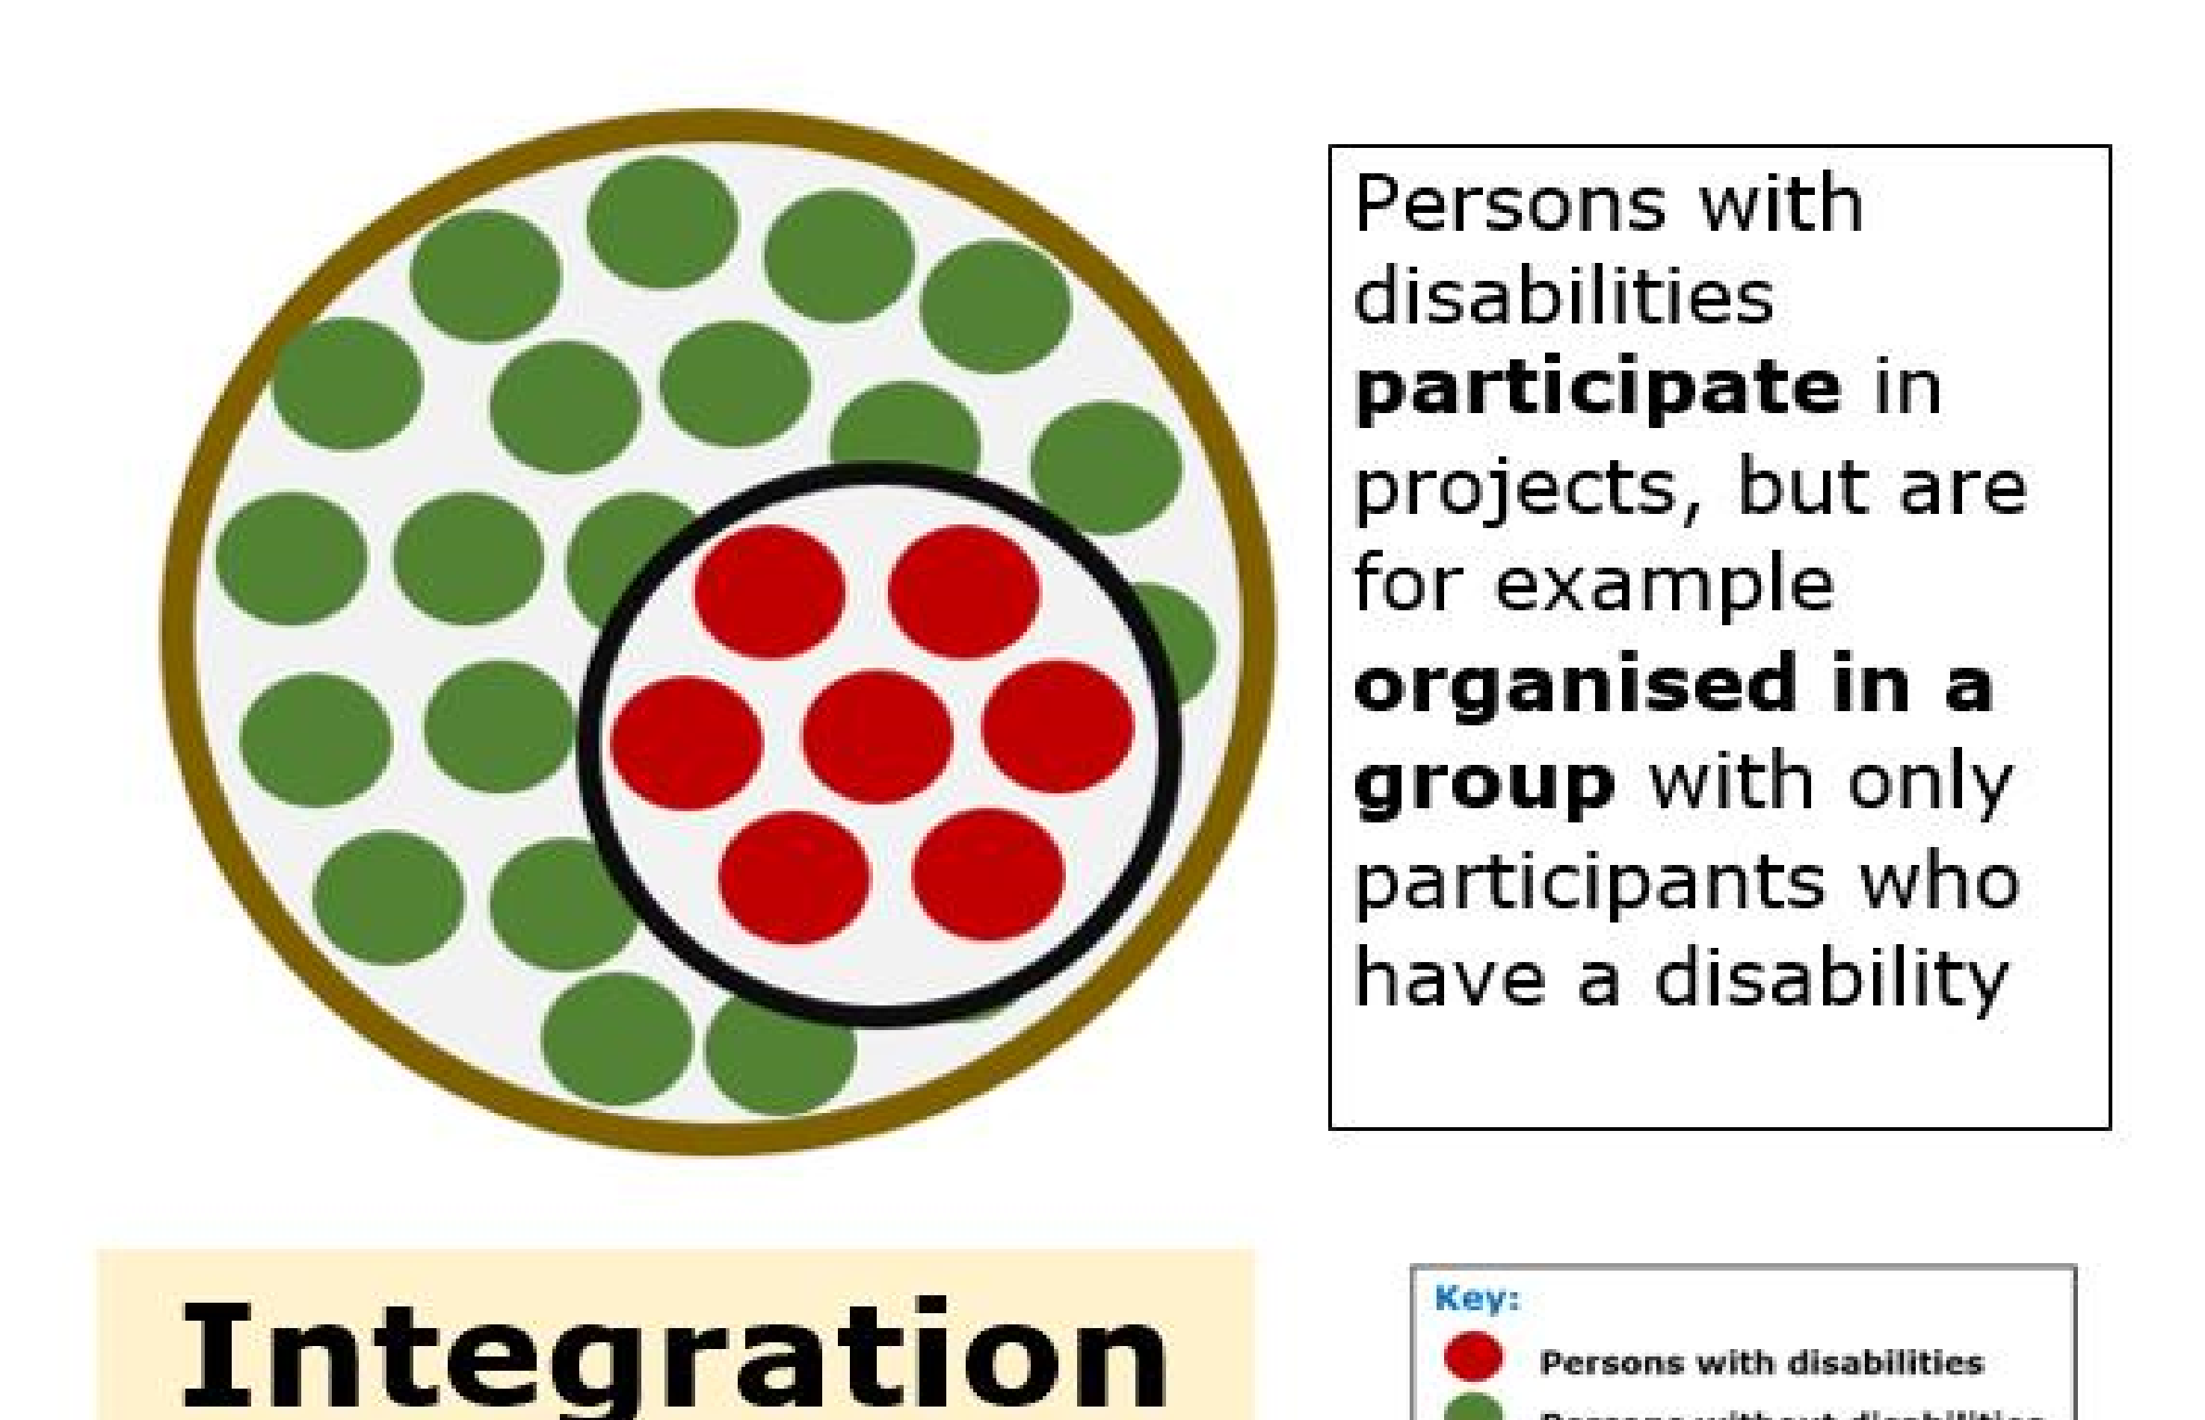
Integration

Inclusion
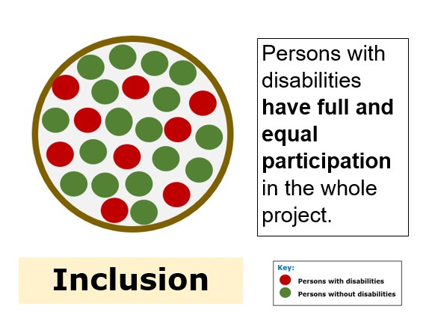
Facts about inclusion:
1.Inclusion is rights based.
2.Comprehensive accessibility is key to ensuring full and effective participation of persons with disabilities in programs.
3.Effective inclusion should not be a stand alone intervention but has to be mainstreamed into regular programs and projects.
4.In this way: equality, non-discrimination, voice, choice and autonomy shall be achieved for all.

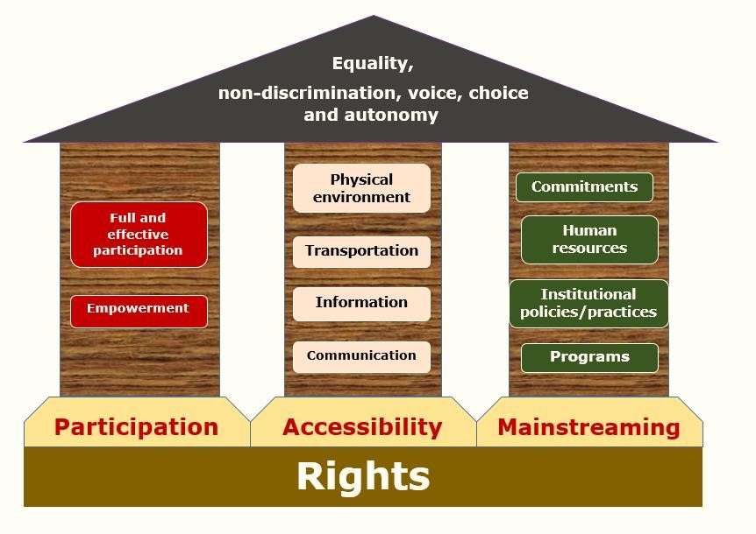
The Inclusion house
Definition of Disability
Disability is “a substantial functional limitation of daily activities caused by the Physical, mental or sensory impairment and environment barriers resulting in limited participation”
“The Persons with Disability Act 2020.
Definition of Persons with Disabilities
Persons with disabilities includes those who have long-term physical, mental, intellectual or sensory impairments which in interaction with various barriers may hinder their full and effective participation in society on an equal basis with others.
(UN Convention on the rights of Persons with
Disabilities, 2006)
Understanding barriers
What are the common barriers that persons with disabilities experience in their daily life/interaction?
Understanding barriers
The major barriers are:
- Accessibility to (information, communication, services, facilities, environment)
- Attitudinal barriers- perception of us
- Barriers to participation( within an individual such as self esteem, illiteracy)
What inclusion issues do we look at:
Economic empowerment | Labour and Employment
Education | Agriculture
Justice | Politics
Health | Transport
Gender | Land ownership
Sports and games | Climate change/DRR
Music, drama and dance

What we look for in…..
• | Health: Policy issues, Early identification, accessibility to health facilities & information, adjustable beds, sunscreen lotions, limited access to drugs for mental health and epilepsy, prevention of disability, Limited financing for rehabilitation services, HMIS is not inclusive,
• | Education: Implementation of Inclusive policy, Need for inclusive ECD, inclusive materials, Need qualtity education standards, few SNE teachers, limited Budgetary allocation to SNE Vs 10% policy as per the Persons with disabilities Act, Sports for CWDs, access to affirmative action, disability data.

• | Social development – Policy implementation,  social exclusion and Discrimination, lack of Reasonable Accommodation etc
• | Science, technology and innovation: Access to adaptive technology, information  &equipment's, Universal design of products and services, JAWS software
• | Local government: Limited financing for disability programmes, poor implementation  of policies, lack of data on disability, limited awareness on disability and “HOW”

• | Office of the President: Slow Implementation of disability commitments and policies, need to champion an inclusive agenda, Need for disability inclusion focal person to monitor the level of inclusion in government programs.
• | Trade & Tourism: Disability inclusion in the sector, access to the tourism information and facilities
• | Urban development: Access to housing facilities, access to water sources, urban floods affecting mobility of persons with disabilities, poor implementation of accessibility building standards.

Reasonable Accommodation
Reasonable accommodation ”means necessary and appropriate modification or adjustments not imposing a
disproportionate or undue burden, where needed in a particular case, to ensure that persons with disabilities enjoy or exercise on an equal basis with others of all human rights and fundamental freedoms”.
Reasonable accommodation needs to be individualize according to the level of difficulty:
i. Some difficulty ii. A lot of difficulty
iii. Can not do at all- need to address complex barriers that are disabling.
Therefore, Persons with some difficulty can have varying needs from those with a lot of difficulty or can not do at all.
Individualization of RA

Disability and Reasonable accommodation.
Disability Reasonable Accommodation
Persons with Physical • Accessibility in terms of ramps or lifts,.
disability • Enough space to maneuver the

Persons with Visual impairment/Blind (depending on the degree of the impairment) environment
- Provision of assistive devices like crutches, wheelchairs, calipers, amputee support.
- Personal assistants- Helpers depending on degree of difficulty
- Laptops with JAWS-(Jobs Access With Speech)
- Large prints- low vision
- Braille / audio information
- Personal Assistants- Guides

Disability Reasonable Accommodation
Persons with Epilepsy • Supportive drugs to avoid seizures
And • Psychological support depending
Persons with Mental on the disability
health /psycho-social • Supportive drugs to avoid lapses disabilities to mental illness.
Persons with Hearing • Sign Language interpreters impairment/ Deaf • Assistive devices - Hearing Aids and universal design of (depending on the technological services.
degree of hearing) • Speech support
- Text captioning
Persons with short Accessibility in terms of Adjustable Stature/ Little persons facilities like seats, desk, transportation
Persons with • Sign language interpreters for
DeafBlindness those who are short sighted
- Use of Tactile communication
Disability
Reasonable accomdoation
Persons with intellectual • Simplified messages through disabilities the support of care takers.
- Need extra time to enable them finish their assignments/speech
- Being patient when they are speaking

Disability Reasonable Accommodation
Persons with Albinism • Use of Large sun protective Hats
- Use of Magnifier lens for reading
- Large prints for those with low vision
- Provision of sun screen lotions for prevention of skin cancer.
Persons With Cerebral • Support services with personal
Palsy writers
- Extra time to enable them finish their assignments/message.
- Being patient when they are speaking
- More space for them to move freely
Question
What happens if disability issues are
not included in the development
process?

Refer to World Bank
- Persons with disabilities are more likely to experience adverse socio-economic outcomes than persons without disabilities, such as less education, poorer health outcomes, lower levels of employment, and higher poverty rates.
- Barriers to full social and economic inclusion of persons with disabilities will persist.
- Disability may increase the risk of poverty, through lack of employment and education opportunities, lower wages, and increased cost of living with a disability.
Continue ….
- Poverty may increase the risk of disability through malnutrition, inadequate access to education and health care, unsafe working conditions, a polluted environment, and lack of access to safe water and sanitation.
- Leads to high dependence on families, government and DPOs
- Middle status income level wont be achieved without planning for persons with disabilities- We need disability inclusion to supplement the Uganda vision 2040.
Brainstorming
What aspects of disability-inclusion do you think should be included in the
planning, implementation, monitoring and evaluation of programme?
-Inclusion
- Awareness of disability and its implications is a crucial first step in development programs.
- Participation of persons with disabilities and DPOs should be promoted.
- Comprehensive accessibility of all services and facilities will ensure that physical, information, communication, policy and attitudinal barriers encountered by persons with disabilities are both identified and addressed.
-Inclusion
- A twin-track approach to identify specific actions for persons with disabilities should be promoted. o Evidence-based planning should be promoted to ensure that stakeholders use context-specific, verifiable data or newly emerging evidence for decision-making.
- Human rights-based approaches needs to be promoted, to ensure that disability planning is underpinned by the recognition of the human rights of persons with disabilities.
-Inclusion
- Gender equality in disability-inclusive planning need to be considered, to address barriers with a differential impact on poverty and development for women, men, girls, and boys’
- Harmonization with national policies and planning frameworks should be adopted by all stakeholders.
- Accountability to be enhanced, through stakeholder involvement, M&E, information sharing, use of evidence and ensuring value for money.

Principles for Disability-Inclusion
- Multi-sectoral collaboration will be applied, to ensure a holistic process that incorporates plans and interventions from all stakeholders involved in disability programming.
- Reasonable accommodation will always be applied, to provide necessary adjustments in procedures, service design and delivery, facilities, or equipment's

Indicative budgetary items for disability inclusion
- Raising awareness on disability – to reduce social and institutional barriers among different stakeholders
- Outreach to raise awareness of a programme among persons with disabilities, who may not have equal access to information
- Workplace adaptations permitting the recruitment of persons with disabilities (e.g. IT and accessible software, ramps, hand rails, braille materials, etc).
- Adaptation of service facilities, to enable access to services by people with disabilities (e.g. ramps, hand rails, use of sign language interpreters, etc.).

Indicative budget items for disability inclusion
- Specific expertise (for disability analysis; or for developing inclusive policies).
- Training of service providers on inclusive practices
- Specific surveys linking disability and the programme, and evaluations to identify good practices.
- Cost of enabling meaningful participation of persons with disabilities/DPOs at different stages of programme design, implementation, and monitoring.
Information sources
- UBOS 2014 and Uganda Functional Difficulties Survey- 2017
- Constitution of Republic of Uganda 1995
- UN Convention on the rights of Persons with Disabilities- 2006
- National Disability Inclusive Planning Guidelines for Uganda – 2017
- Persons with Disabilities Act 2020
- CRPD Concluding Observations 2016- UHRC
- Gender and Equity Compacts

Conclusion
As staff of NUDIPU, We all have a role to play in line with available national and international
commitments to promote inclusion of persons
with disabilities in the development process.
Thank you for your attention

